***Sohaib Sarosh Shamsi***

***21K-3278 Section E***

Q1. Write a recursive function that checks whether a number is a palindrome.

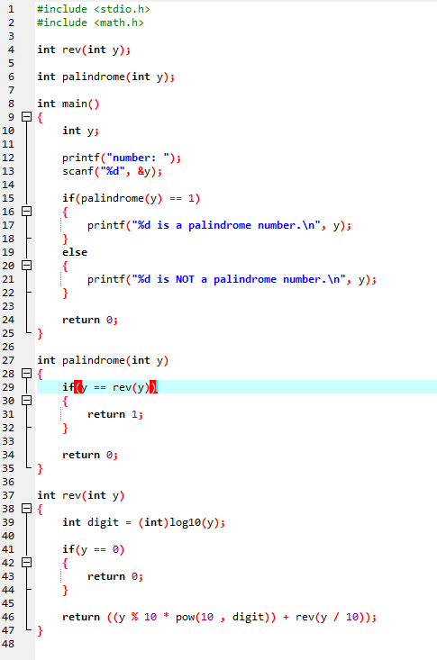

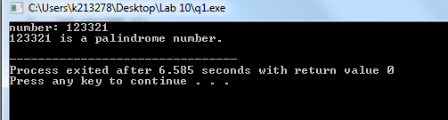

Q2. write a program to find the lcm of two numbers using recursion.

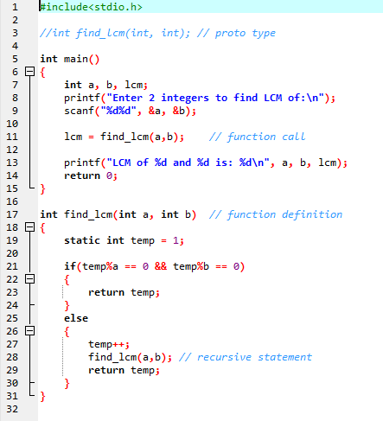

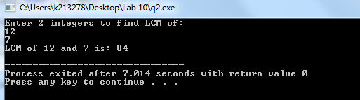

Q3. A phone number, such as (212) 767-8900, can be thought of as having three parts: e.g., the area

code (212), the exchange (767), and the number (8900). Write a program that uses a structure to

store these three parts of a phone number separately. Call the structure phone.

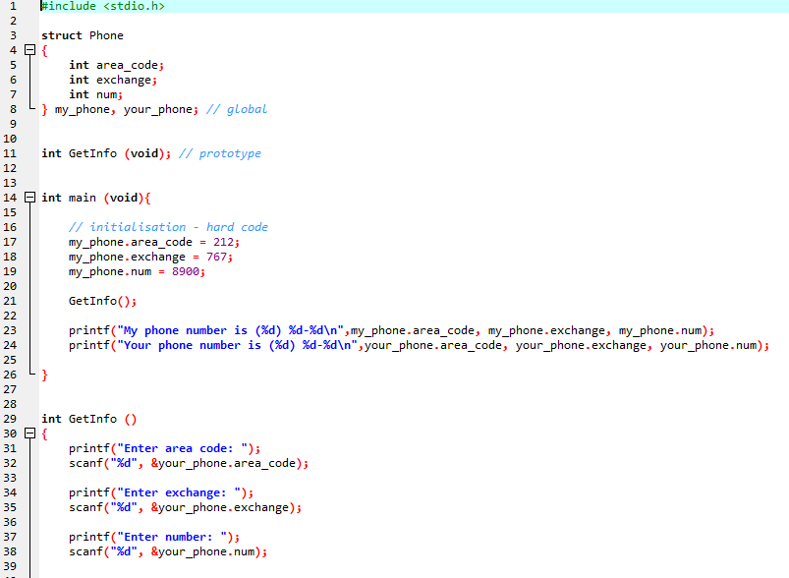

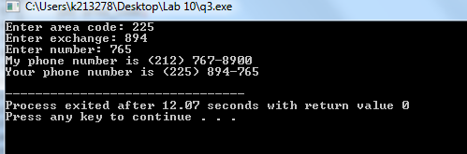

Q4. Write a C Program to Store Information of N Students Using Structure, where N is provided by

the user. Student information should contain Student_id, stu_age, stu_name; street no; state; city;

country;

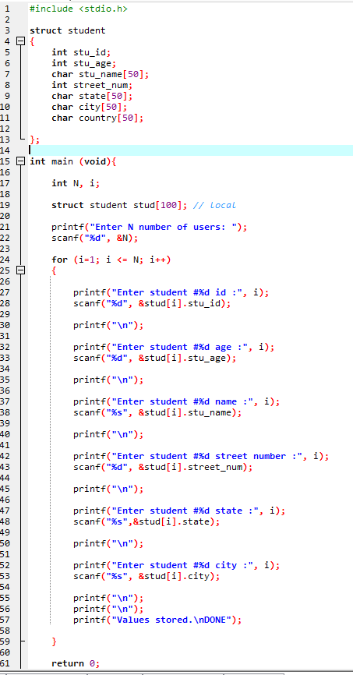

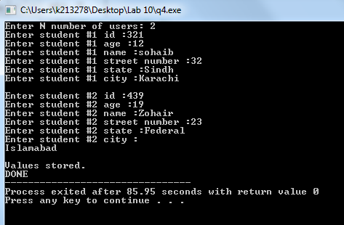

Q5. Write a C program that uses functions to perform the following operations:

i) Reading a complex number ii) Writing a complex number iii) Addition of two complex numbers iv) Multiplication of two complex numbers (Note: represent complex numbers using a structure.)

